
Registration Form
Starred (*) Fields are mandatory to fill in
*Title:
*Full Name:
*Address

*Post Code:
*Do you live alone? (Circle the appropriate) Yes / No / Prefer not to say
*Home Phone:
Mobile:
Email Address:
*Gender:
*Date Of Birth / /
*Emergency Contact Name & Relation
*Home Phone: *Mobile
2nd Emergency Contact Name & Relation
* Home Phone: *Mobile
What is the main reason for your application? (Please circle)
Age Area/ Rural Disability Universal Credit Registered Disabled
Other (please specify) :

Where did you hear about us?

What is the main reason for using the service? Eg. Medical Appointments, Leisure, Shopping

Additional Information If you are willing, we would be grateful if you could provide us with additional information. This can help us with grant funding, enable us to provide services to those who need it most & establish equality for all. This section is not mandatory but very helpful.
Please tick the appropriate boxes.
Housing |  | Employment
Home Owner |  | Employed Full Time
Council Rented |  | Employed Part Time
Private Rented |  | Retired
Homeless |  | Unpaid / Voluntary
Assisted Living / Care Home |  | Unemployed
Other (Please Specify Below) |  | Unable To Work
 |  | Student
 |  | Full-Time Parent

Ethnicity
White British |  | White & Asian
White Irish |  | Arab
White Gypsy / Irish Traveller |  | Bangladeshi
Any Other White Background |  | Chinese
White & Black African |  | Indian
White & Black Caribbean |  | Pakistani
African |  | Any Other Asian Background
Caribbean |  | Any Other Mixed Background
Any Other Black Background |  | Any Other Ethnic Group

Do you receive care or support? (Eg. From family or care provider and how often)
Are you a carer or support another person? (Please Circle) Yes No
Disabilities – So that we can make sure we have the best support in place for you and that you can travel comfortably, please tick any of the applicable/current disabilities.
It is not mandatory that you complete this section.
- Downs Syndrome
- Mental Health / Anxiety / Phobia
- Mobility
- Respiratory Issues
- Speech Difficulties
- Visually Impaired
- Other :

- Alzheimer’s / Dementia
- Cancer
- Epilepsy
- Hearing Difficulties
- Heart Condition
- Hemiplegia / Stroke
- Learning Difficulties

Any Other Information We Should Know?
Eg. Medical issues, Access To Property Instructions, Additional Travel Requirements

*Mobility Aids, please select the aids you will be traveling with – THIS SECTION IS MANDATORY*
- Frame / Rollator
- Scooter
- Shopping Trolley
- Walking Stick
- Crutches
- Escort / Carer / Assistant
*Wheelchair Users (Please Circle One) – THIS SECTION IS MANDATORY IF YOU USE A CHAIR*
What type of chair do you use?
Electric Wheelchair Manual Wheelchair
Do you wish to travel in your chair or transfer to a seat?
Travel In Wheelchair Transfer to bus seat
If you wish to travel in your wheelchair, we must check that your chair is crash tested. To check this, we need to know the make and model of your wheelchair.
Make & Model of your wheelchair (Eg. Lomax Unit 9 Transit Wheelchair)
Make: Model:
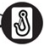
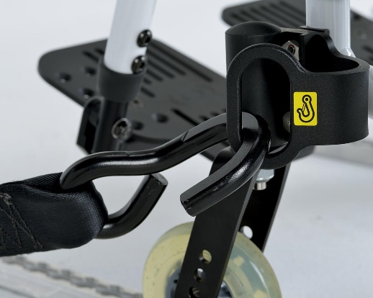
Does your chair have clamp points with the sticker shown
Yes No

PLEASE NOTE
If you use a wheelchair, it is possible for you to remain in the chair if you are unable to transfer to a seat however the wheelchair must have been Crash Tested by the manufacturer. If you use an electric scooter, you will need to be able to transfer to a bus seat once you have boarded the vehicle. The scooter can be transported with you to your destination.
If you are unsure if your chair has been crash tested, if you have a sticker with an ISO number (eg. ISO 7176-19) on your chair then it has been!
Journey payment:
We have three ways to pay for your convenience. Please circle which option you would prefer:
- Cash Payment On The Day Of Travel
- Card Payment (Contactless or Chip & Pin) On The Day Of Travel – Preferable
- Invoiced Monthly

If you wish to be invoiced call 01444 471919 or fill in the details below:
Name of payee:
Email:
Contact Number:
SEND TO
Bluebird Community Transport
Wivelsden Farm
North Common Road
North Chailey
East Sussex
BN8 4EH

Or email to:
enquiry@ctsussex.org.uk

* I confirm that I have read & understood the information contained in this letter and that all information given by me is true and correct.
In this pack, you are being asked to submit personal information about yourself (e.g. name and e-mail address) in order to receive or use our services. These include all the services available to members of CT Sussex (Bluebird Community Transport). By entering your details in the fields requested; you enable CT Sussex to provide you with the services available to members. Any personal information you provide to us will only be used by us, our agents, and service providers, and will not be disclosed unless we are obliged or permitted by law to do so.
If not signed by the passenger, please note name & relation
Signed Date



Welcome to Bluebird Community Transport. Thank you for joining our community transport service.
No membership fee is required, however, as a registered charity a donation is always gratefully received with thanks. If you wish to make a voluntary donation, you may do so using the form below. A one-off donation is lovely, but if you wish to make a small regular donation (perhaps £2 a month) you can fill out and return the standing order form. Of course, if you wish to make a larger donation that would be wonderful.
To make a one-off donation, please make a cheque out to Community Transport Sussex and return it to our address.
To make a regular donation, please fill in the standing order form below and send it directly to your bank.
If you want to make either kind of donation, please also fill out the Gift Aid slip enclosed
Standing Order Form
To The Manager (Your Branch Address)
____________________________________________
___________________________________________Post Code:_______________
I hereby authorise and request you to debit my account
Account Name: ________________________________________________
Account Number Sort Code The Amount Of
 |  |  |  |  |  |  |  |  |  |  | - |  |  | - |  |  |  | £ |  |  | Monthly
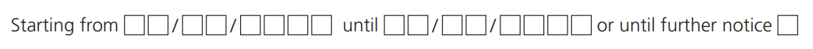
And Credit:
Community Transport Sussex - Account no: 00029230 – Sort Code: 40-52-40
Name (Block Capitals) Date Signed

Please also complete the Gift Aid slip enclosed. Thank you for your generosity
Please return this form to your own bank so that they may set up your standing order. Standing Orders have to be processed by the individuals own bank and not the receiver of the donation. Many thanks.

